Admin Oracle

With all the correct log in credentials we can log in to the admin dash board .

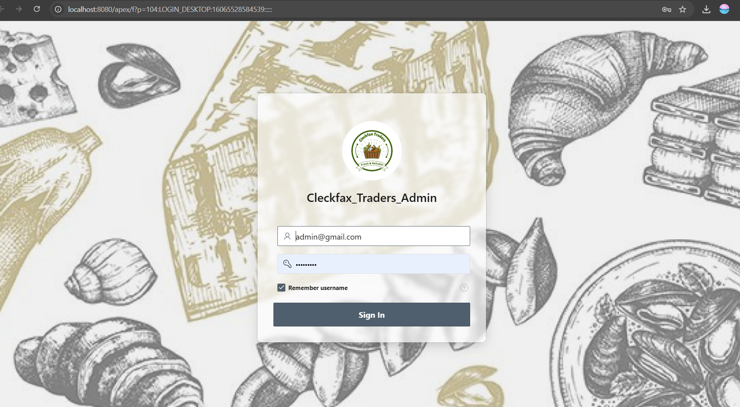

The text marks the failed login screen and asks testers to check error messages and security features. It makes sure errors are clear and the system stays safe.

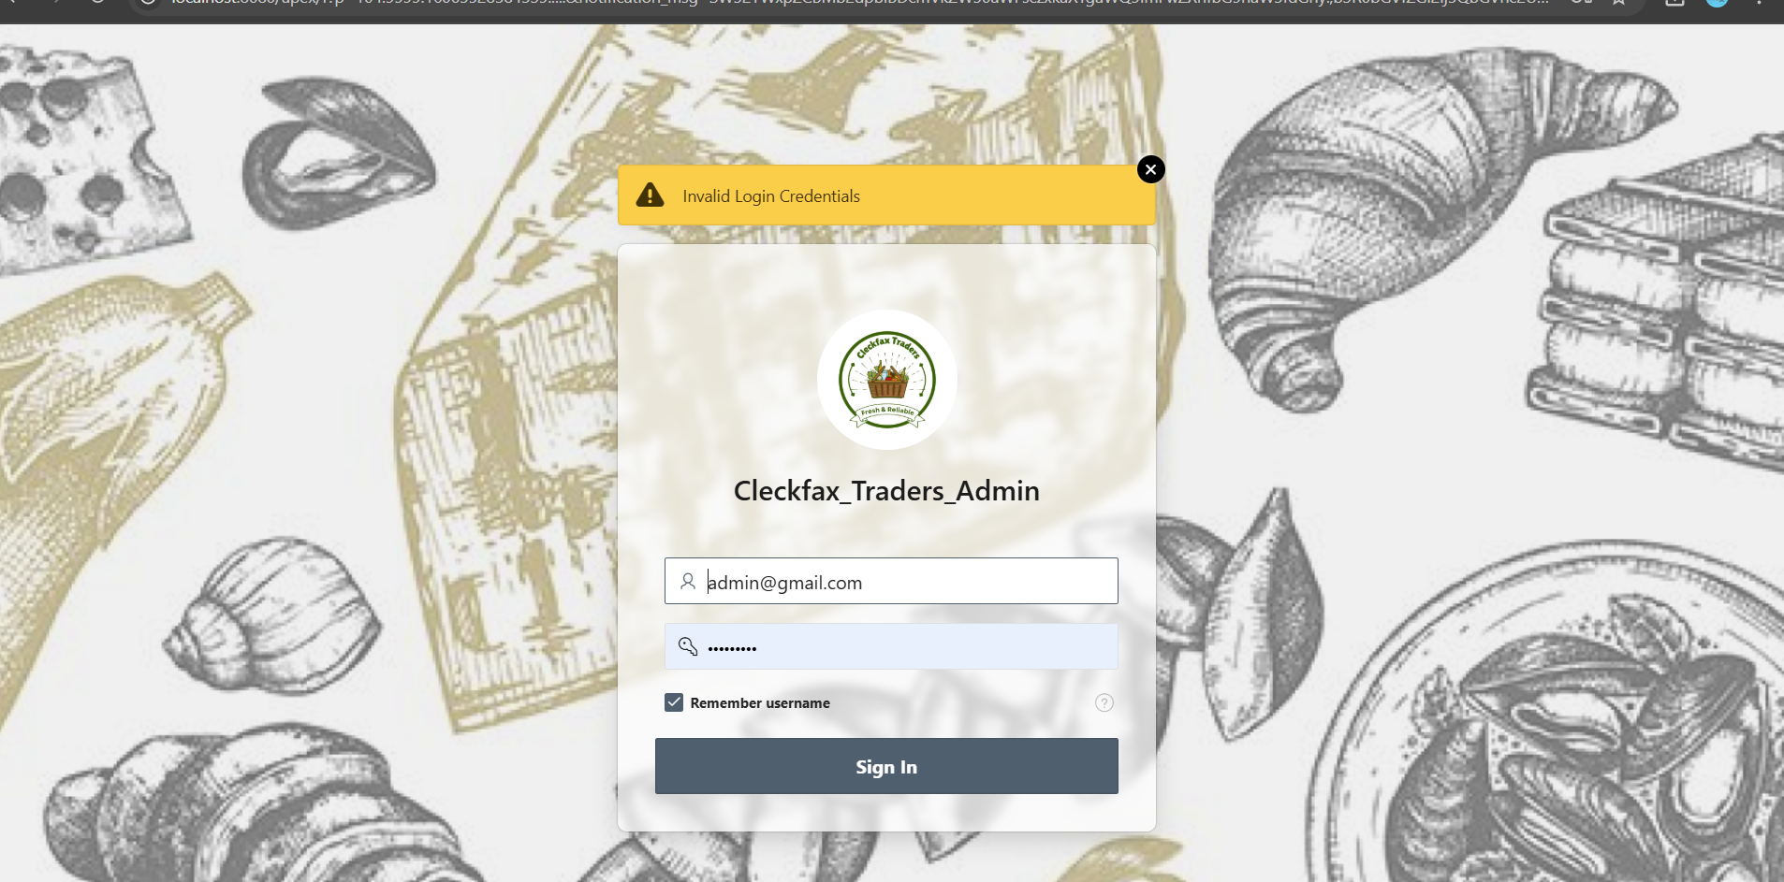

After log in we can go through the admin dashboard. the admin dashboard guides to check if data shows correctly and the page runs fast. It ensures admins can see and use data easily.

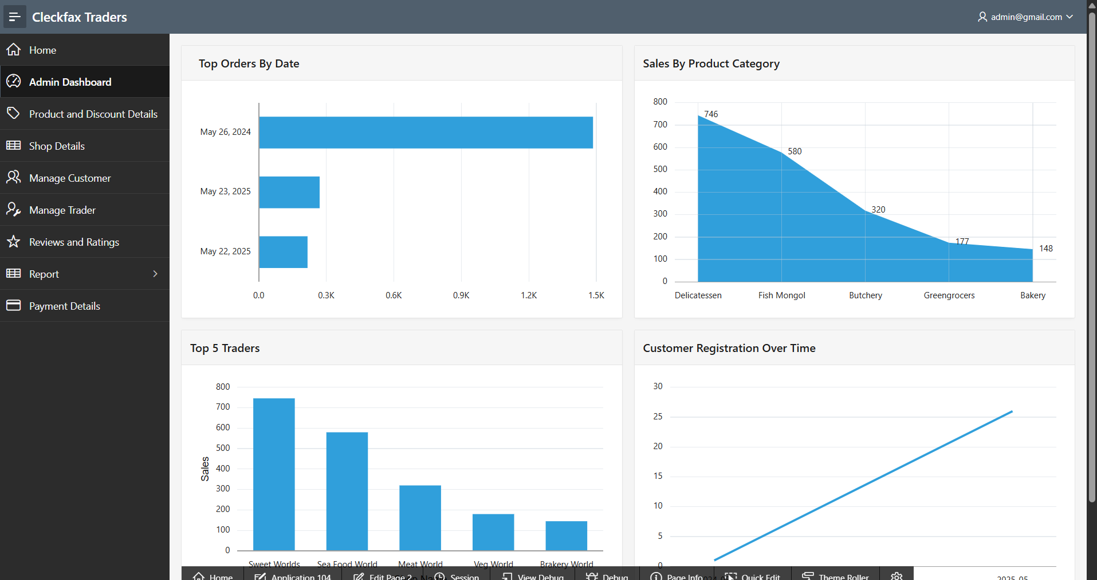

Once the admin can access the dash board admin can check the shop details. It helps make sure the shop shows correct products and is easy to browse.

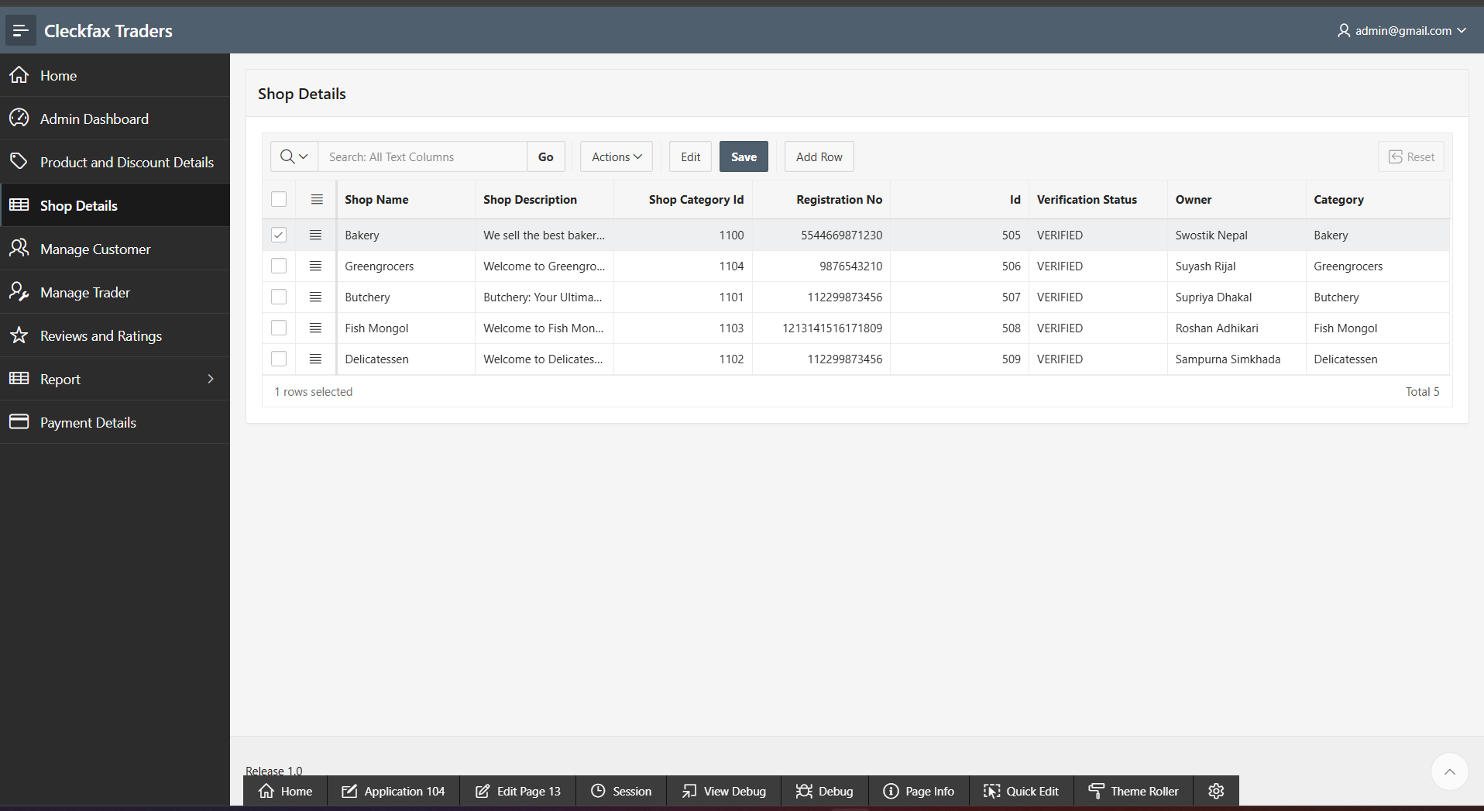

Admin can also go the list of customers, manage them or can also remove them if any suspicious deeds is found

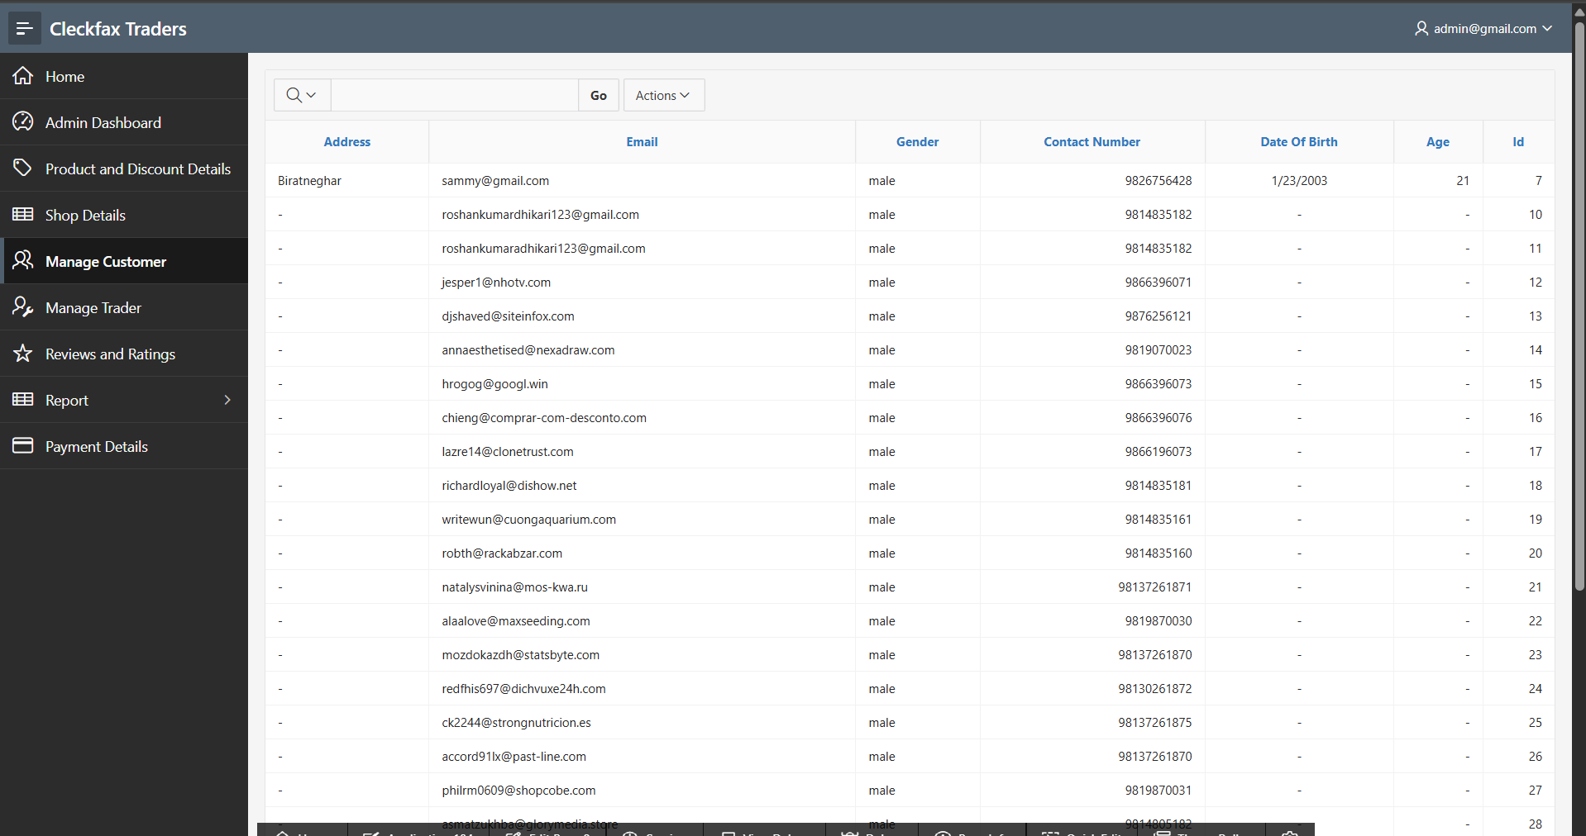

Admin can also go through the product and the discount details , adding them deleting them or making any other necessary changes

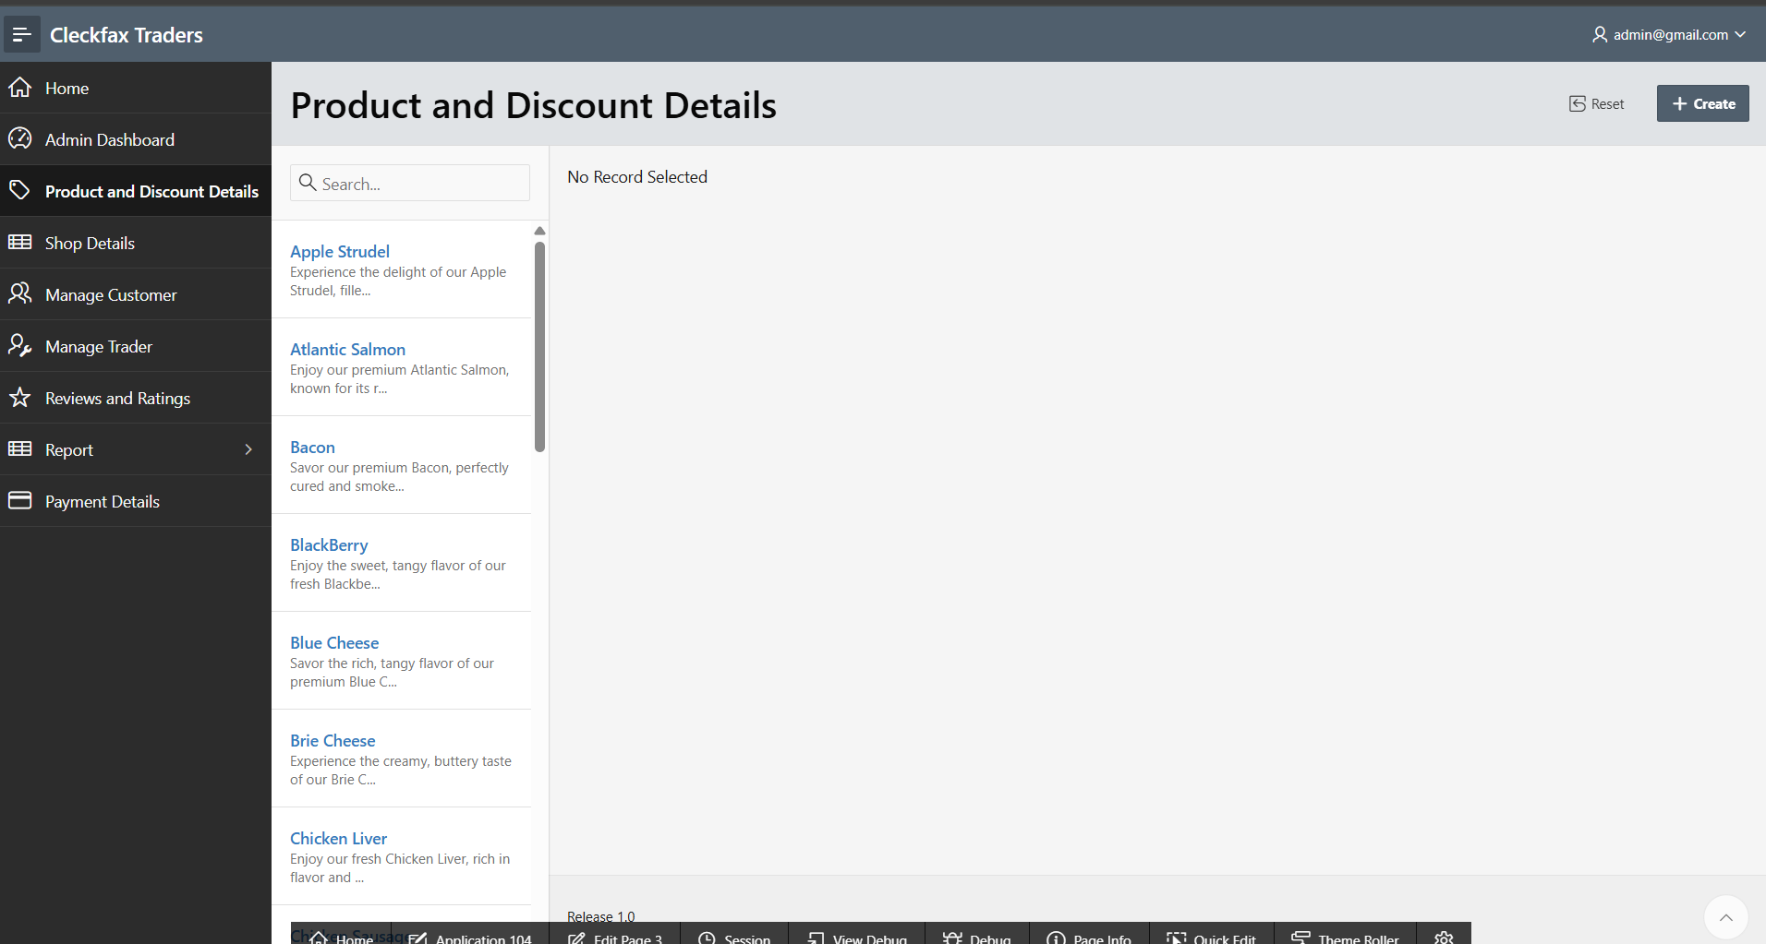

Admin will also have the access to all the traders profile checking their works and viewing the reports regularly

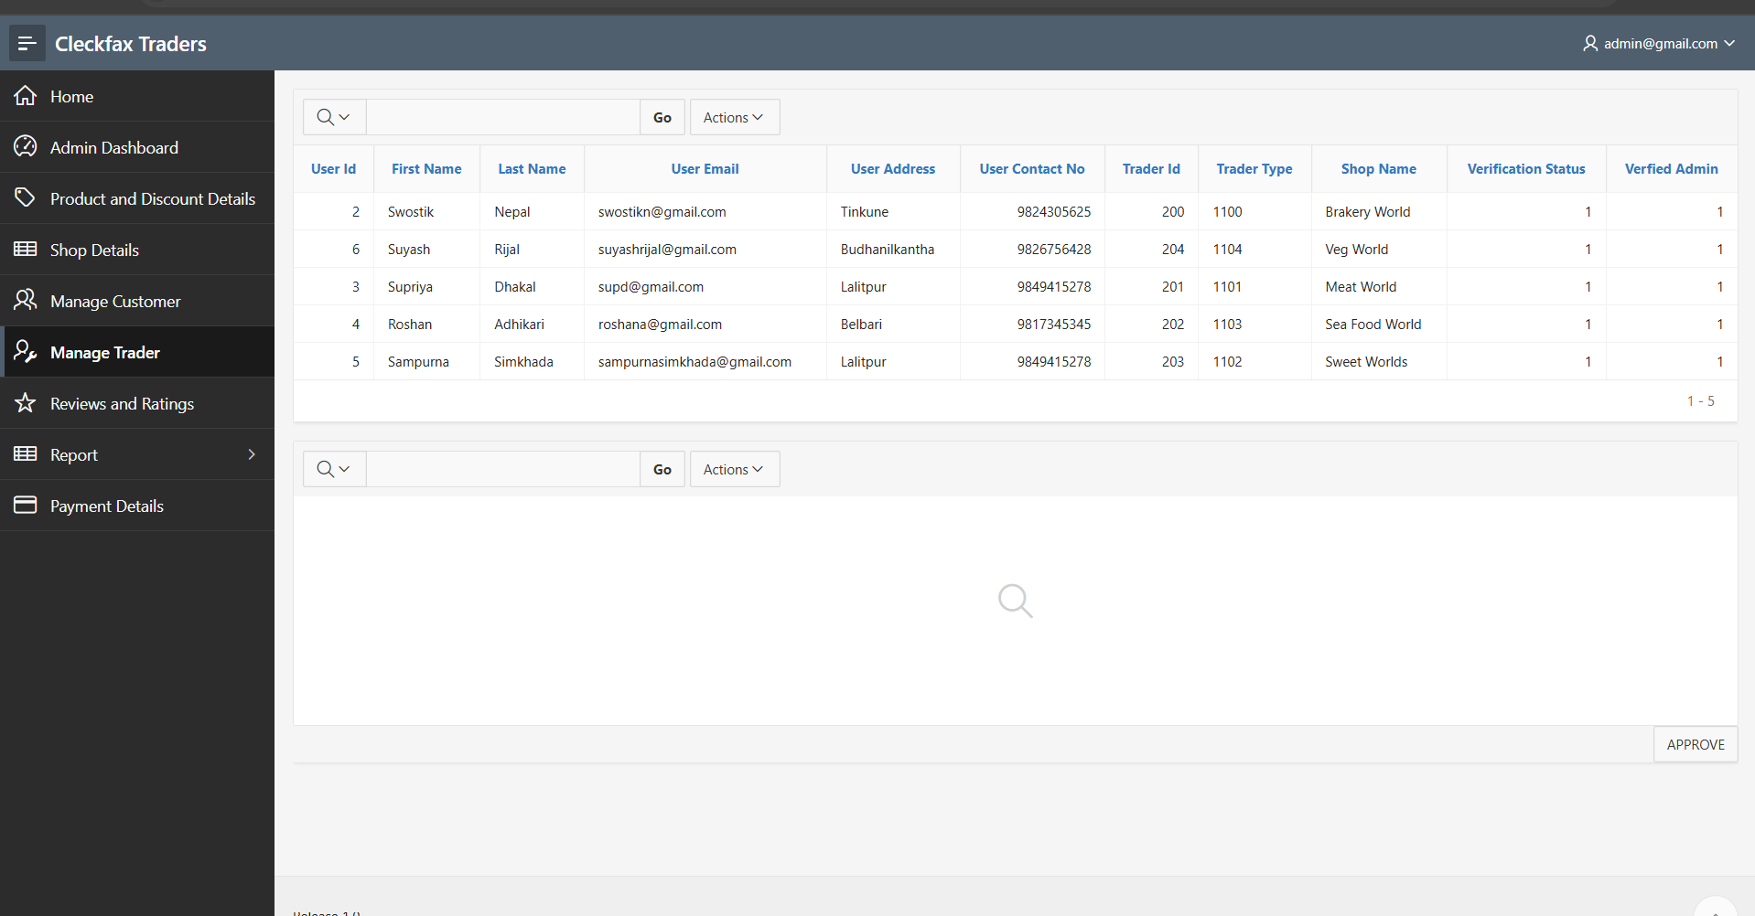

Review and ratings can also ne checked by the admin and filter out all the reviews.

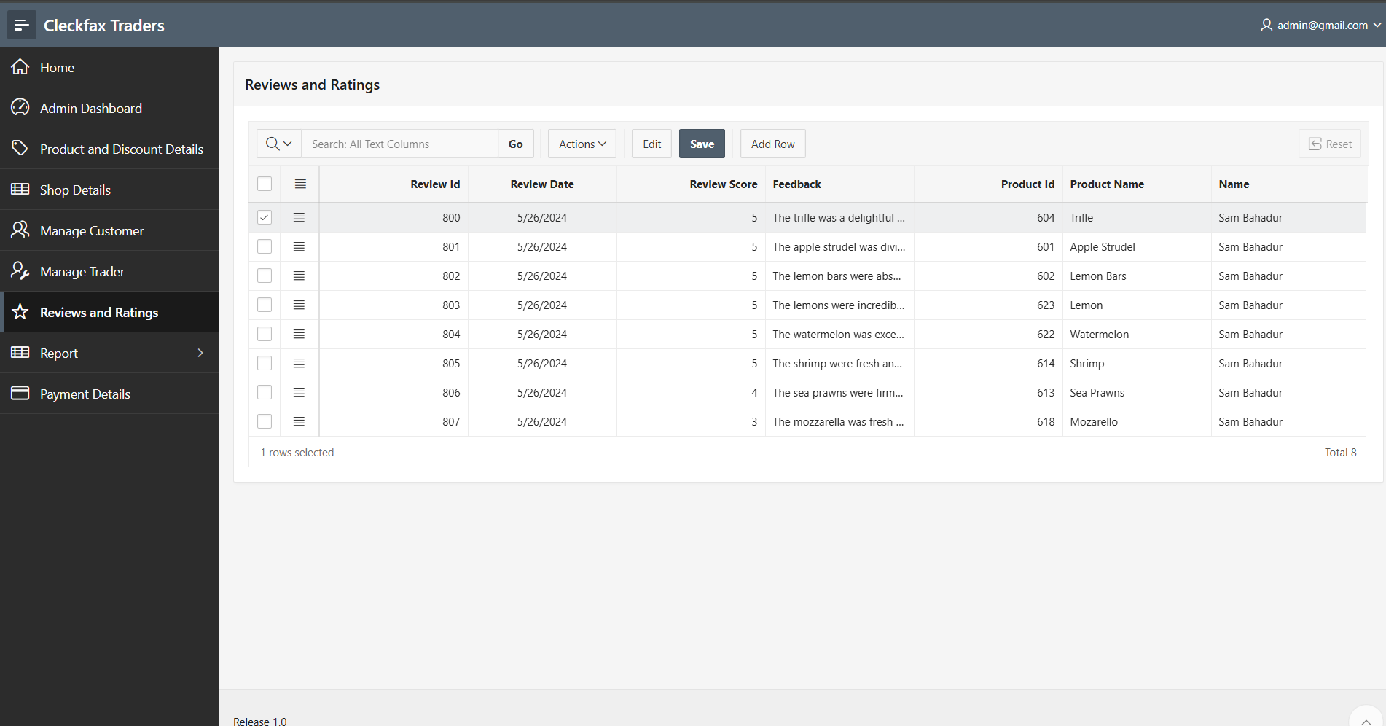

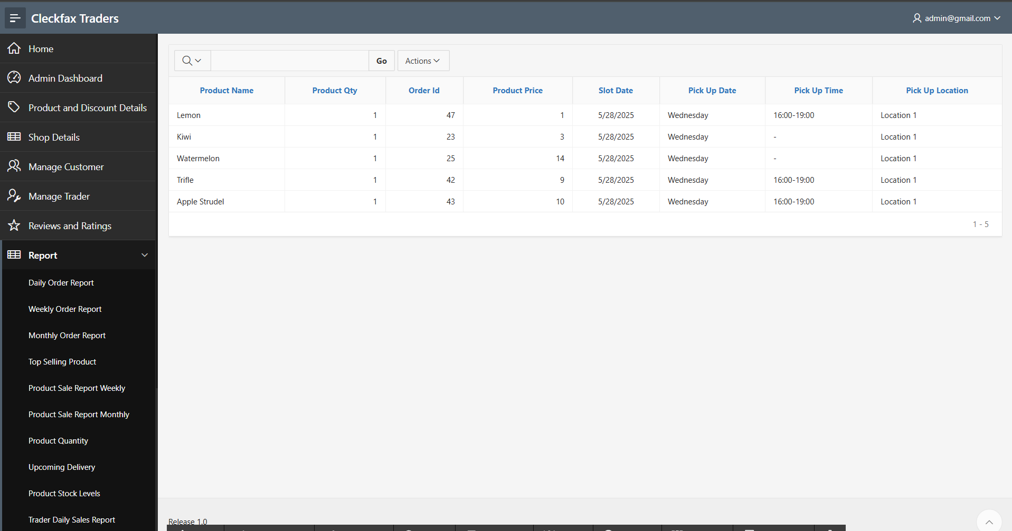

Admin will also get the report daily, weekly and monthly report .

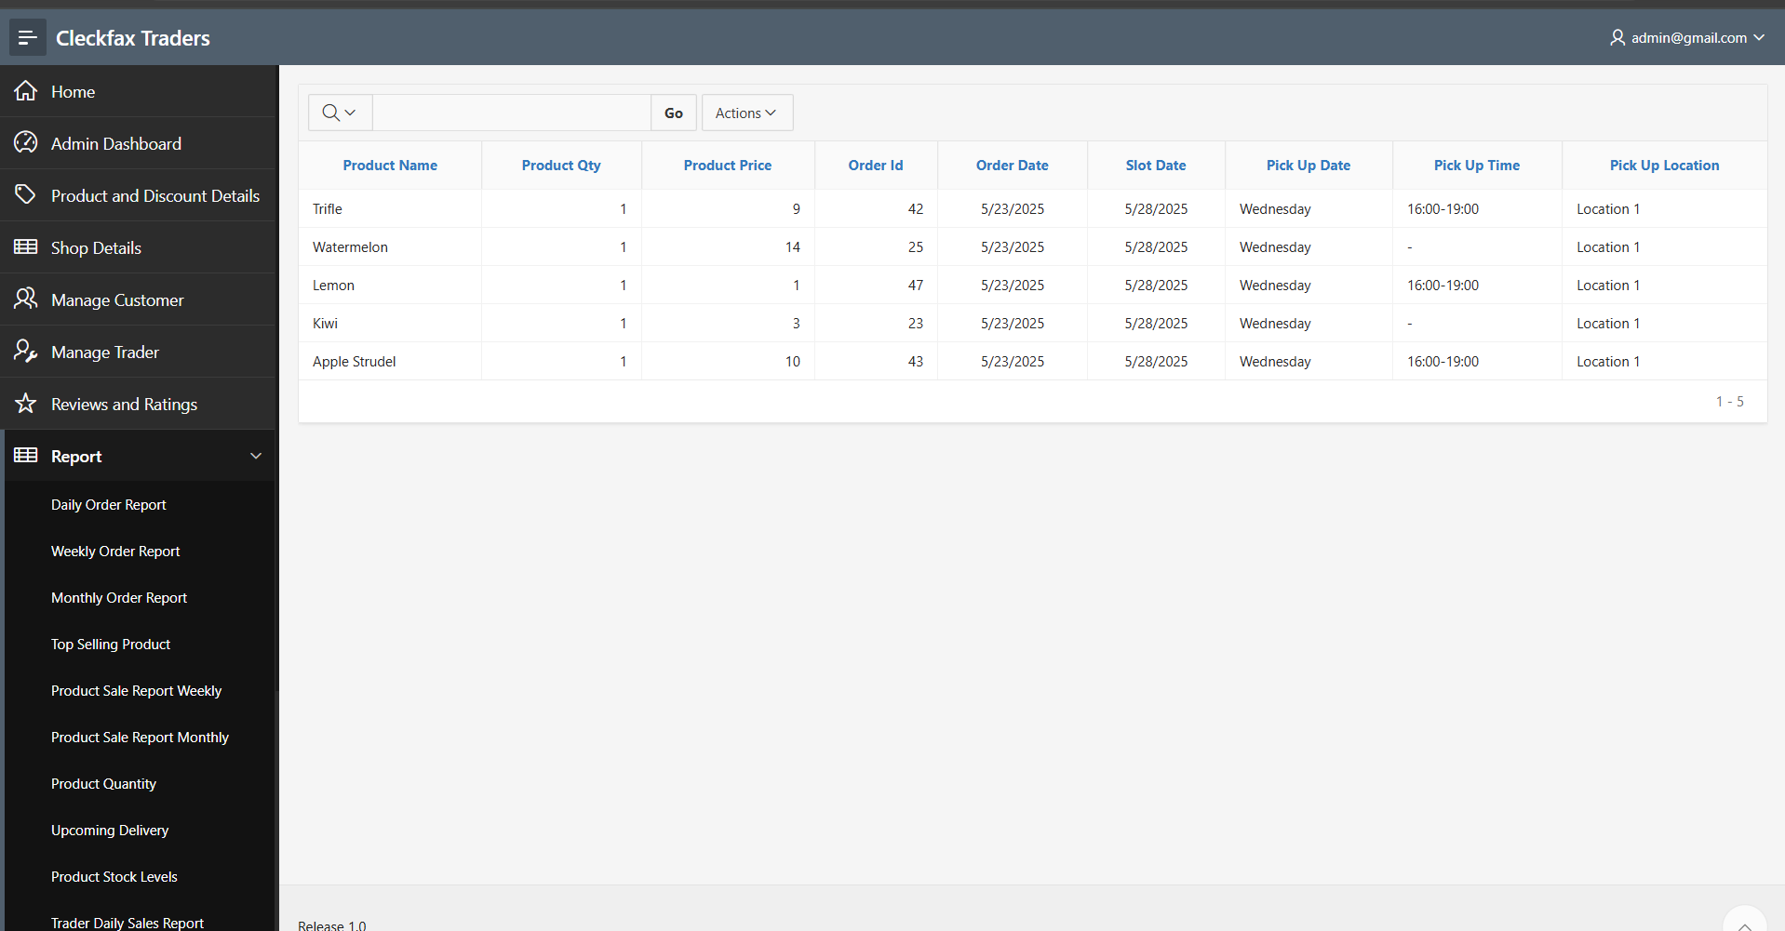

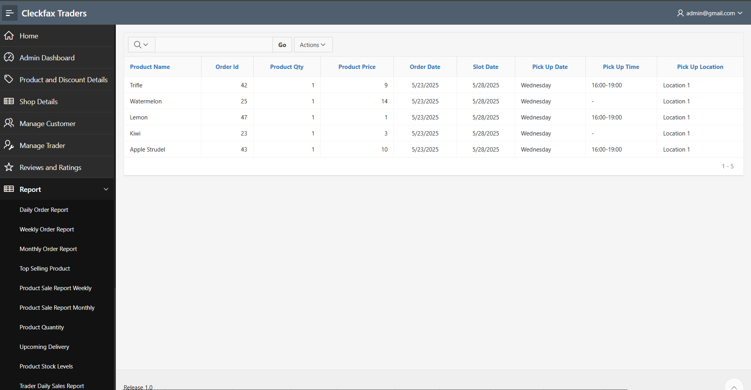

With the monthly review trader can also view the report of top selling product , sales report by category – daily, weekly and monthly.

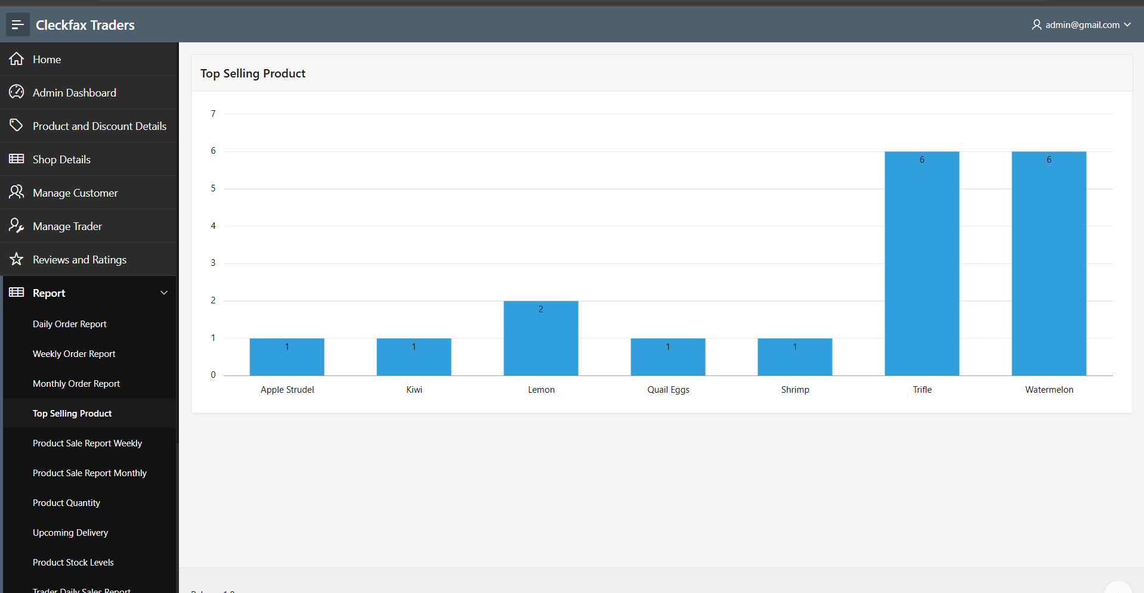

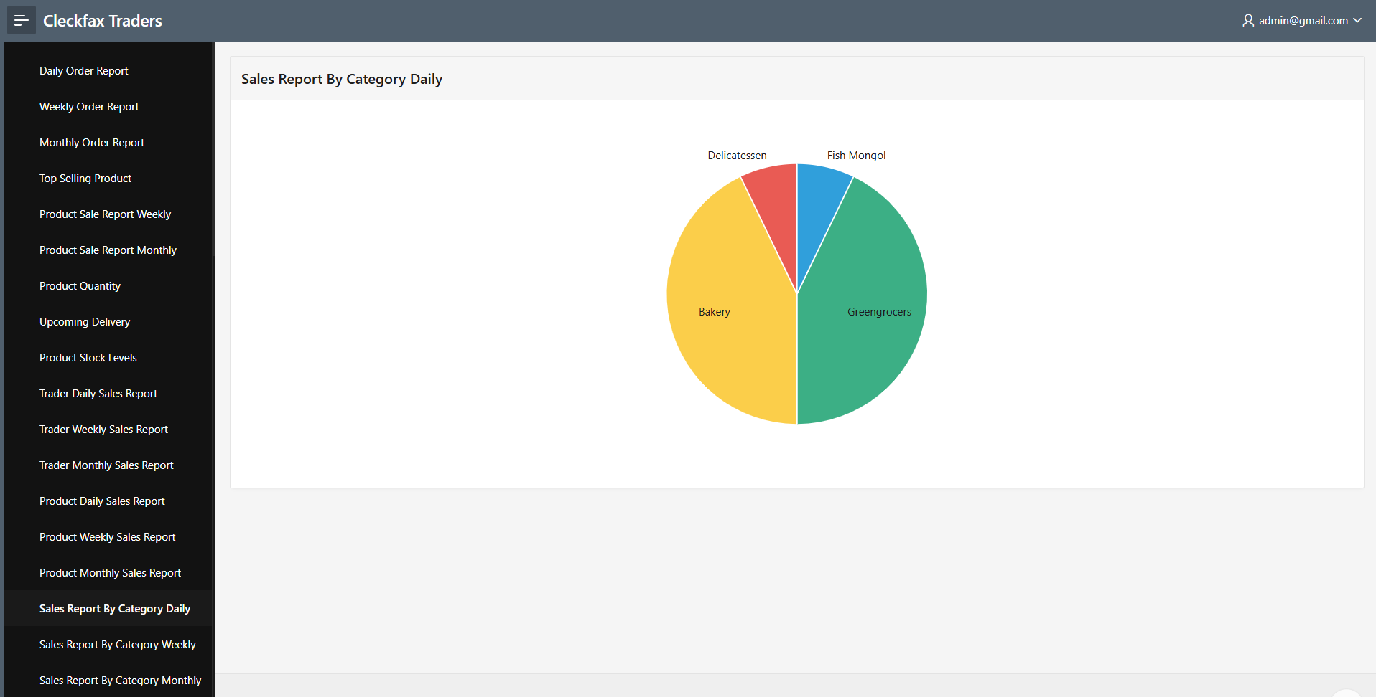

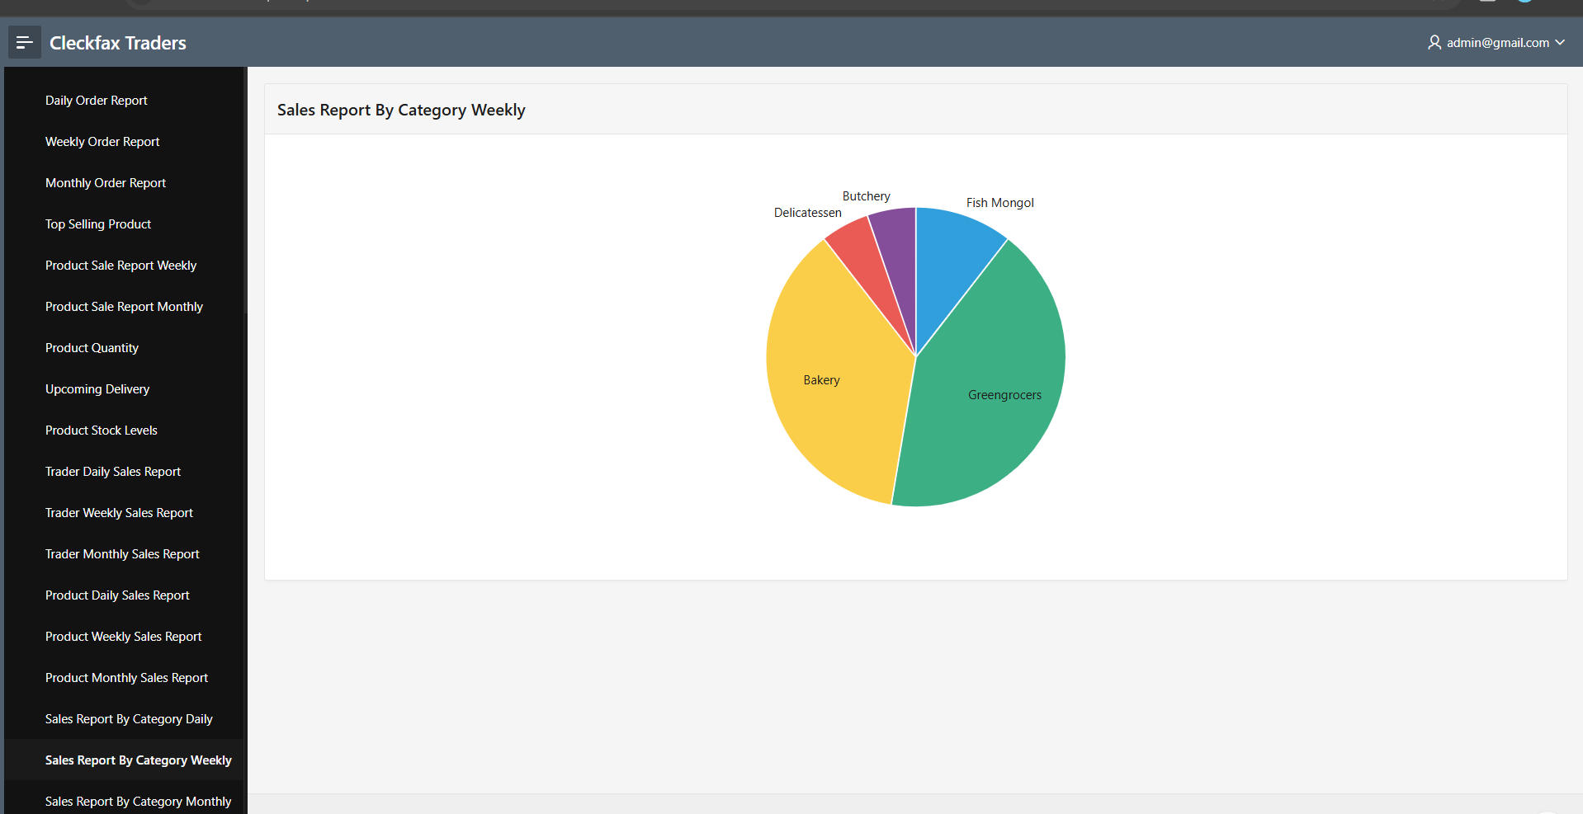

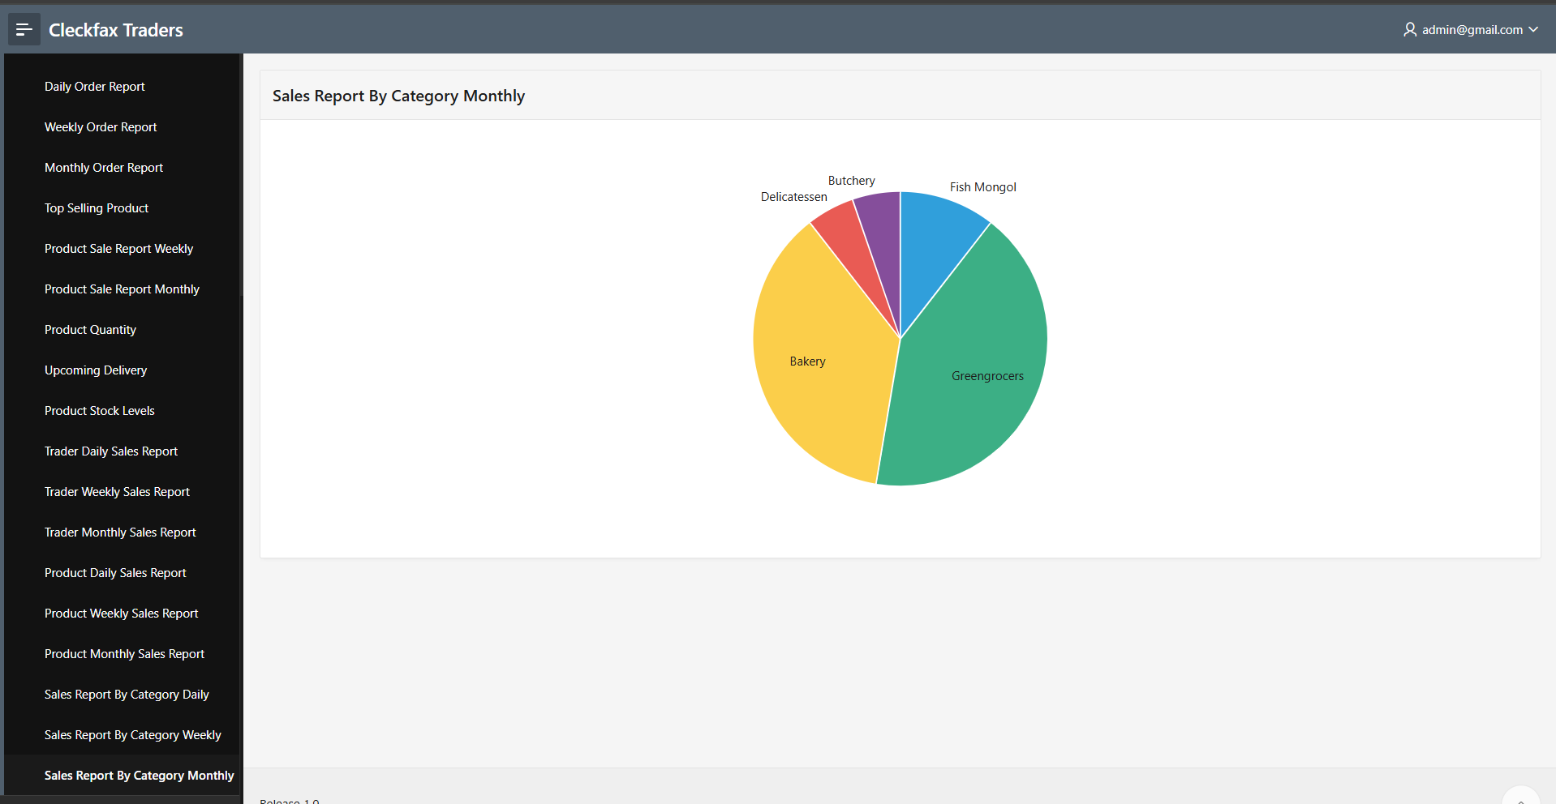

The report of the payments can also be viewed by the admin

